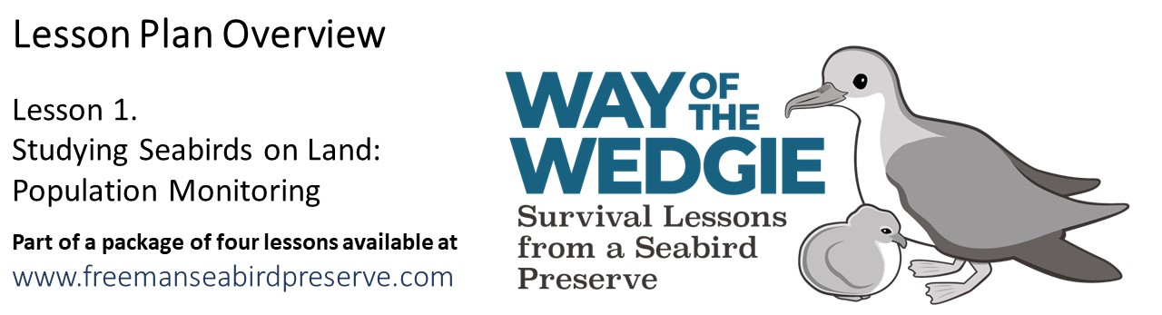

Evaluate: The Life Cycle of a Wedge-tailed Shearwater

Wedge-tailed Shearwaters at the Freeman Seabird Preserve begin breeding around five or six years of age. They arrive at the preserve in March and begin courting prospective mates. Once a mate is found, mating occurs in May, and egg-laying begins in early June. Parents take turns incubating their eggs until early August, when chicks begin to hatch from their eggs. Chicks stay in their nesting sites until mid November, being fed by their parents, and begin to leave the nests as fledglings in early November. Fledging continues until December. Young birds will spend the next 4-5 years at sea, before returning to the preserve to find a mate.

The diagram below shows the annual breeding cycle of Wedge-tailed Shearwaters, indicating the monthly schedule of adult migration (outer circle) and reproduction (inner circle). The thickness of the lines indicates their abundance at colonies: thick line indicates higher numbers and thin line indicates lower numbers.

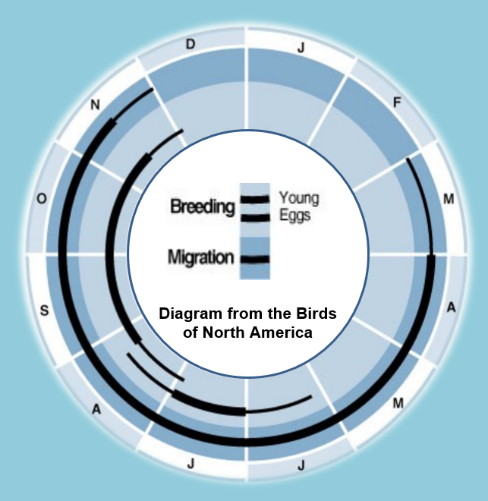
Shearwater Life Cycle

There are no birds at the colony between early December and late February.

Adults start returning to the colony in early March, with peak numbers from early April to mid November.

By early December, parents stop returning to the colony to feed their chicks.

Eggs are laid in early June, with peak numbers in July.

Chicks start hatching in late July, and have all hatched by late August.

Fledging chicks start leaving the colony in mid November and have all left by early December. Some undeveloped chicks may fledge as late as mid December.
Using this diagram and what you have learned so far about the life of the Wedge-tailed Shearwaters, use the spaces provided to draw and describe “The Story of a Wedge-tailed Shearwater Chick” at the Freeman Seabird Preserve. Be creative, you can tell the story from the perspective of the parents, the chick, or the researchers.

“The Story of a Wedge-tailed Shearwater Chick”
March - April | ______________________________________________________  ______________________________________________________  ______________________________________________________  ______________________________________________________  ______________________________________________________
May | ______________________________________________________  ______________________________________________________  ______________________________________________________  ______________________________________________________  ______________________________________________________
June - July | ______________________________________________________  ______________________________________________________  ______________________________________________________  ______________________________________________________  ______________________________________________________
August | ______________________________________________________  ______________________________________________________  ______________________________________________________  ______________________________________________________  ______________________________________________________
September - October | ______________________________________________________  ______________________________________________________  ______________________________________________________  ______________________________________________________  ______________________________________________________
November | ______________________________________________________  ______________________________________________________  ______________________________________________________  ______________________________________________________  ______________________________________________________

December – February | ______________________________________________________  ______________________________________________________  ______________________________________________________  ______________________________________________________  ______________________________________________________
March – May (five years later) | ______________________________________________________  ______________________________________________________  ______________________________________________________  ______________________________________________________  ______________________________________________________
June - July | ______________________________________________________  ______________________________________________________  ______________________________________________________  ______________________________________________________  ______________________________________________________
August | ______________________________________________________  ______________________________________________________  ______________________________________________________  ______________________________________________________  ______________________________________________________

“A Wedge-tailed Shearwater Family Portrait”

