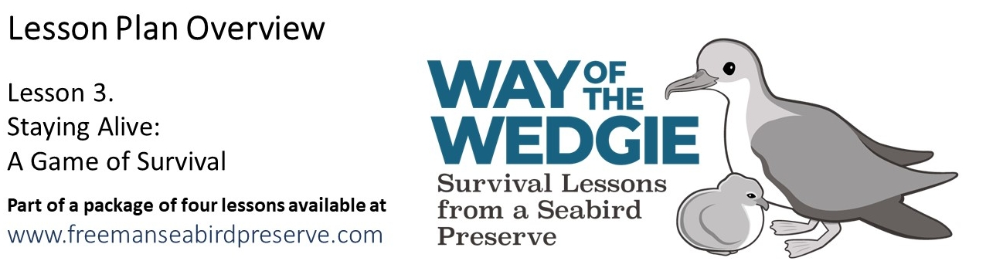
Explore & Explain: The Shearwater Journey - Interactive Game

Now that you have learned about the life cycle of the Wedge-tailed Shearwater, it is time to experience why they are a protected species. In this activity you will take on the role of a Wedge-tailed Shearwater from the Freeman Seabird Preserve and experience different threats throughout your life cycle. You will also get to consider some of the management actions that help ensure the survival of this species. Follow the directions below to complete this activity.

Directions for Becoming a Wedge-tailed Shearwater

- You will notice that there are a number of stations around the room. Each station is labeled and color-coded, and involves a different part of the life cycle and a different dice, with specific outcomes.

- Everyone’s adult shearwater will begin at the “Ocean Station”, during the migration period.

- You will take turns rolling the die, to see if you are ready to go to the colony to breed. When you are ready to breed, you will move to the “Nesting Station”… and so on.

- As you move from station to station, follow the directions written on the die.

- Every student must record the result of their rolls and tally how many of their adult shearwaters died and how many chicks have successfully fledged. Use tick marks in the “tally” boxes provided.

- The instructor will determine how much time students have to complete this activity or how many adult shearwaters they start with. Once all of your adult shearwaters have died, you are done.

- The game is over when all the students have run out of their adult shearwaters.

- Make sure to record all of your dice roll results in the following table, provided below.

- Your class will use the three provided tables for data collection and analysis.

- For the short game: The student who produces more fledged chicks wins.

- For the long game: The student who produces more chicks that recruit wins.
Table 1. Summary Data – The Shearwater Journey

Life Events | Your Total (Tally) | Class Total  (Number)
How did your adult shearwater(s) die ?
Killed by a predator on the colony
Entangled in marine debris at sea
How successful were the mating attempts ?
Number of visits to the mating station
Number of eggs laid
Number of chicks that fledged
How successful were the chicks ?
Number of laid eggs that hatched
Number of hatched chicks that fledged
Number of fledged chicks that survived the juvenile period and recruited to adult population
(NOTE: use only for the long game)

Table 2. Detailed Data – The Shearwater Journey

Life Events | Your Total (Tally) | Class Total  (Number)
Nesting Station:
Record the number of nests made
...in a burrow underground
...on the ground, under plants
...on the ground, in the open
...in a lava rock cave
...in an artificial rock pile
...in an artificial ceramic nest
Egg Station:
Number of eggs laid
Number of eggs eaten by predators
Number of eggs cracked
Number of eggs kicked out and lost
Chick Station:
Number of chicks that hatched
Number of chicks that fledged
Number of chicks killed by a predator
Fledging Station:
Number of successful fledgling chicks
Number of chicks that are grounded
Number of chicks that washed on a beach
Human Interaction Station:
Number of chicks killed by predators
Number of chicks rescued by humans

Table 3. Reproductive Success Calculations – The Shearwater Journey

Calculations | Your Value  (%) | Class Value  (%)
Hatching Success
(chicks hatched / eggs laid) * 100%
Fledging Success
(chicks fledged / chicks hatched) * 100%
Reproductive Success
(chicks fledged / eggs laid) * 100%
Recruitment Success
(chicks recruited / chicks fledged) * 100%
(NOTE: use only for the long game)
Basic Game Discussion Questions

- What type of nest did you lay your egg in?
Describe how this may have affected the success (or lack of success) of your egg hatching.

___________________________________________________________________________________

___________________________________________________________________________________

- List some of the threats to the egg and chick survival you experienced. Describe how protecting the native habitat of Wedge-tailed Shearwaters might help eliminate some of these threats.

___________________________________________________________________________________

___________________________________________________________________________________

___________________________________________________________________________________

- Name one human impact to Wedge-tailed Shearwater survival and describe one way you might help to eliminate this threat.

___________________________________________________________________________________

___________________________________________________________________________________

___________________________________________________________________________________

- Sometimes rats eat Wedge-tailed Shearwater eggs and chicks. Describe a method you believe might help eliminate this problem.

___________________________________________________________________________________

___________________________________________________________________________________

___________________________________________________________________________________

- Sometimes cats and dogs attack and kill Wedge-tailed Shearwaters. Describe a method you believe might help eliminate this problem.

___________________________________________________________________________________

___________________________________________________________________________________

___________________________________________________________________________________

- Describe the ideal land environment that would ensure the safety and successful breeding and survival of the Wedge-tailed Shearwater population.

___________________________________________________________________________________

___________________________________________________________________________________

___________________________________________________________________________________

Advanced Game Discussion Questions

- What were the main causes of mortality for shearwater adults and for shearwater chicks?

___________________________________________________________________________________

___________________________________________________________________________________

___________________________________________________________________________________

- Which of these causes of mortality occur on land (at the Freeman Seabird Preserve) or at sea?

___________________________________________________________________________________

___________________________________________________________________________________

___________________________________________________________________________________

- Which of these causes of mortality would you target? Explain Why.

___________________________________________________________________________________

___________________________________________________________________________________

___________________________________________________________________________________

- What would you do to mitigate these causes of mortality? Explain How.

___________________________________________________________________________________

___________________________________________________________________________________

___________________________________________________________________________________

