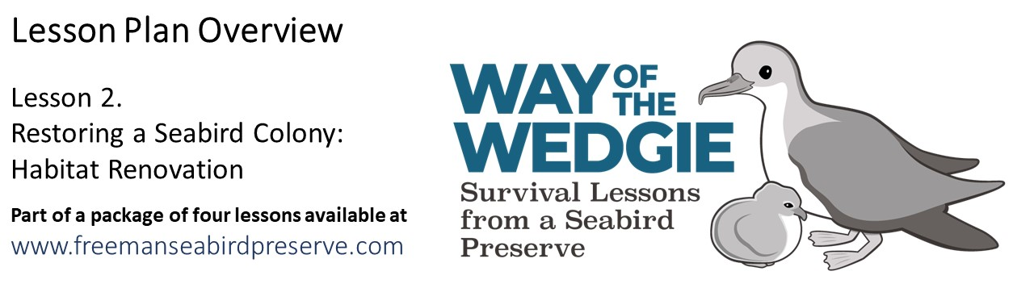Explain & Evaluate: House Hunters
– Wedge-tailed Shearwater Edition
Imagine you are an adult Wedge-tailed Shearwater looking for the perfect new nesting site. You are concerned with finding a home that offers protection from predators, shields you from heavy rains, and offers your chick a cool and shady place to live. Use the information you learned in the previous lessons and observations of the photos below to evaluate each nest type based on the following criteria.
How well does this nest offer protection from these five threats:

- Rat - can poke holes in eggs, eat small chicks
Rats forage above and under ground, and can squeeze through small spaces.

- Cat - can eat small and large chicks, and adults
Cats cannot squeeze through small spaces or cannot move rocks.

- Dog - can kill chicks and adults, and destroy nests
Dogs cannot squeeze through small spaces, but can move rocks and dig.

- Rain - can flood nests, make the inside of the nest muddy
Eggs and chicks in flooded nests can die due to thermal stress.

- Heat – direct sunlight and a lack of wind increase air temperature inside the nest
Eggs and chicks can overheat and die due to thermal stress.
Underground nests stay cool because they can absorb a lot of heat.
Shade (from plants and artificial structures) can keep eggs and chicks cool.

Directions:
Examine the 6 sets of photos below, showing the outside and inside of each nest structure. Evaluate each nest structure by scoring how well it protects from each of 5 listed threats (5 being full protection and 1 being no protection at all). Then add up the points for each nest type to give it a total score. The higher the score the better (safer) the nest design.
Natural - Open Air  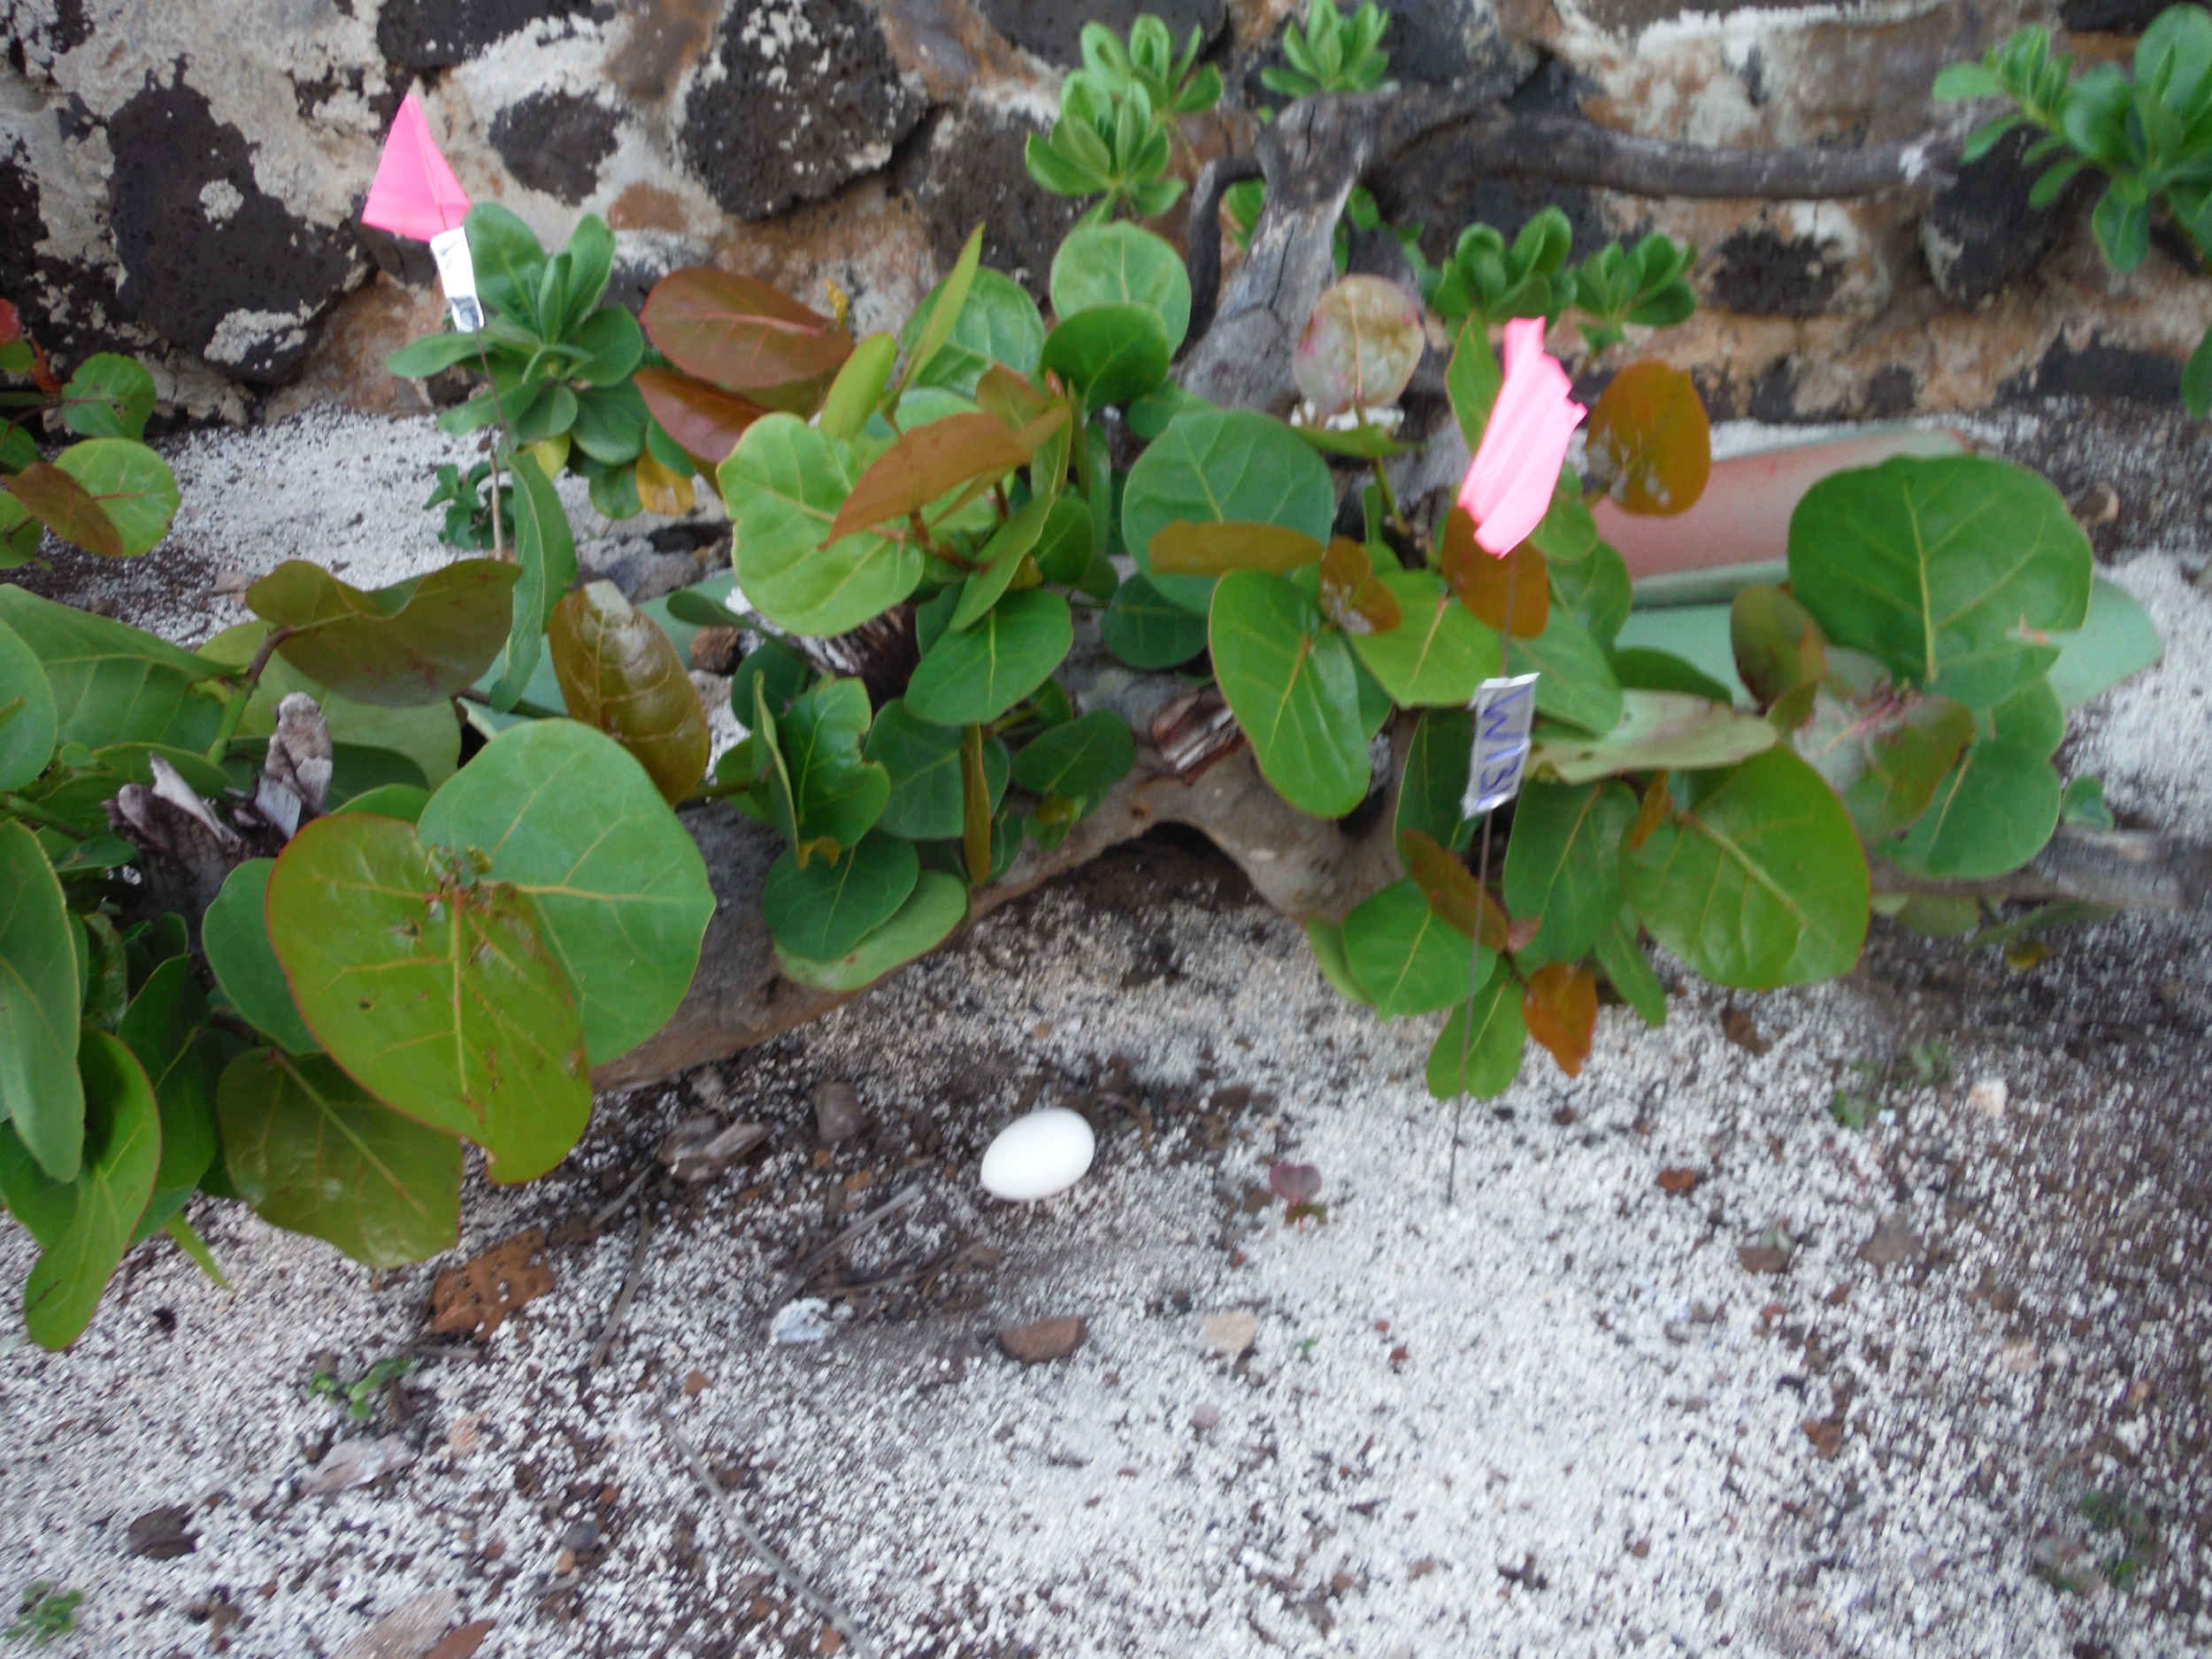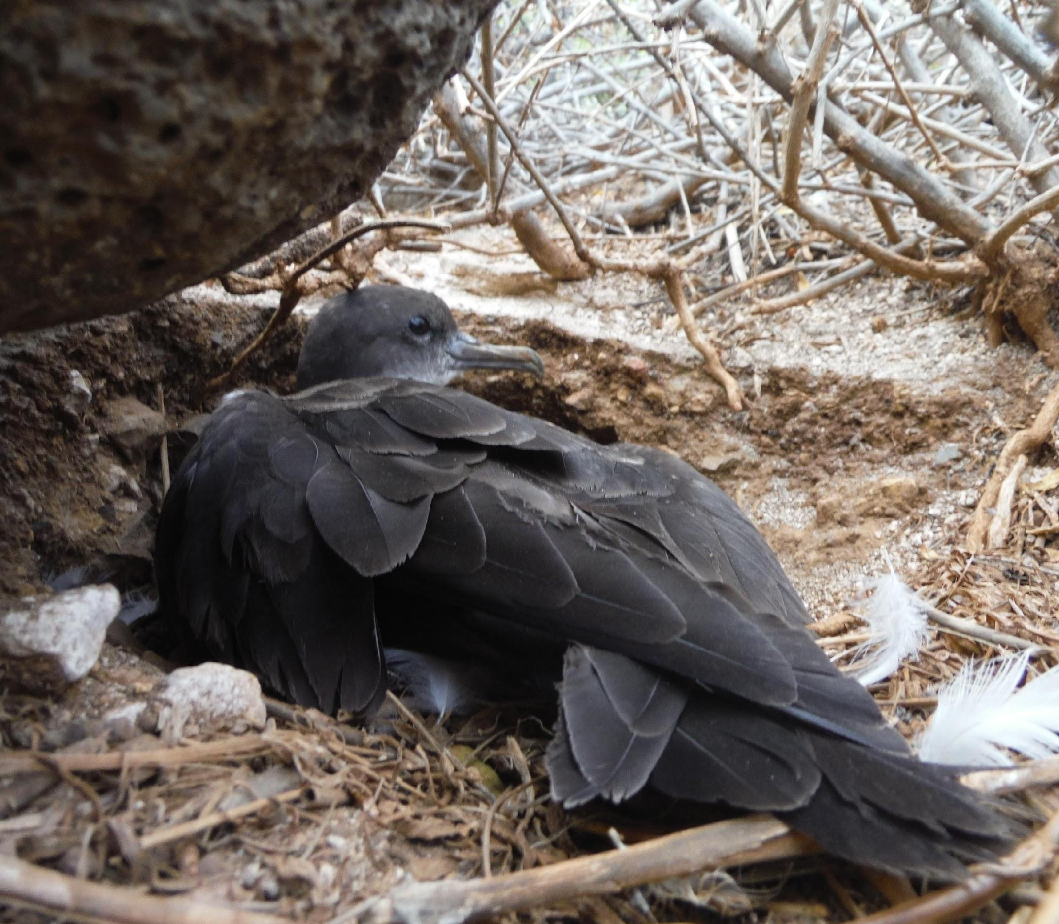 | No Some Full  protection protection protection  1 2 3 4 5  Rat predation 1 2 3 4 5  Cat predation 1 2 3 4 5  Dog predation 1 2 3 4 5  Rain & flooding 1 2 3 4 5  Sunlight & heat 1 2 3 4 5  Total Score: 6  What is this nest’s best features:  There may be some protection from sunlight and heat, if the nesting site is under bushes.
Natural - Burrow in ground  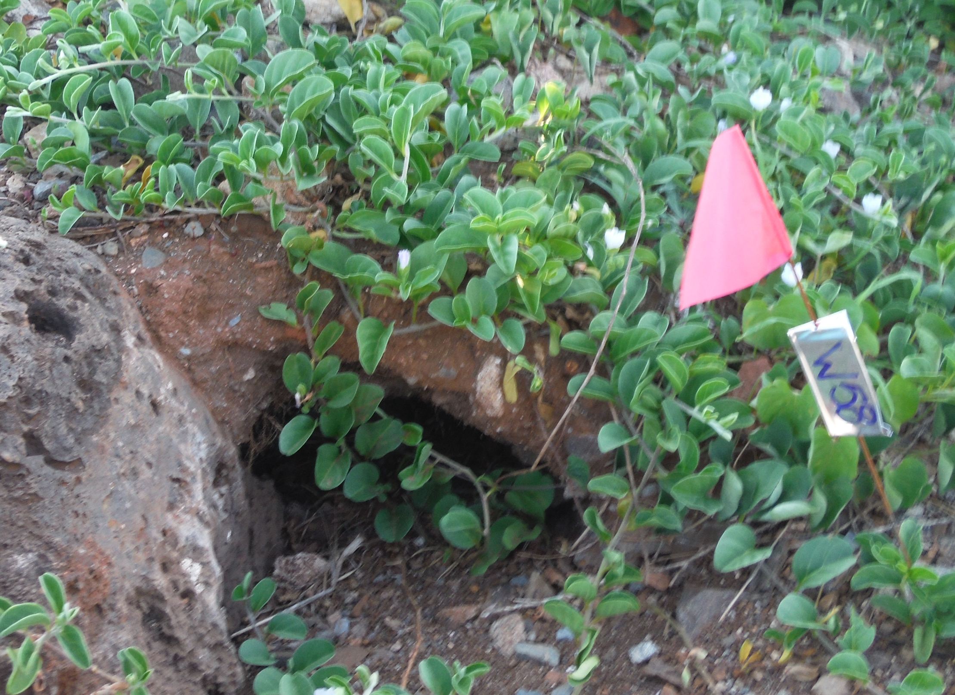  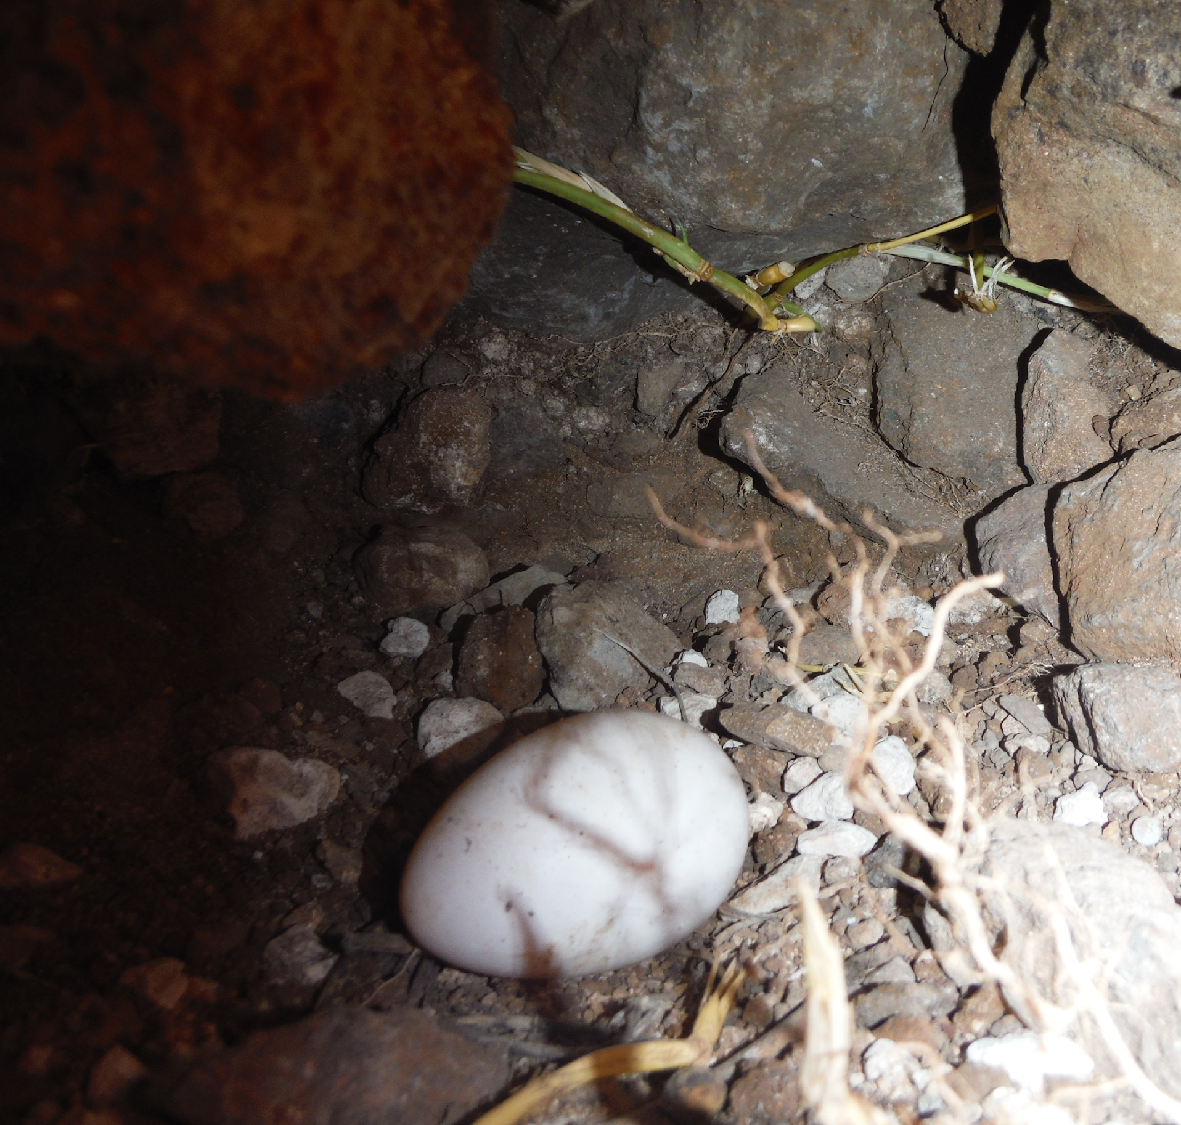 | No Some Full  protection protection protection  1 2 3 4 5  Rat predation 1 2 3 4 5  Cat predation 1 2 3 4 5  Dog predation 1 2 3 4 5  Rain & flooding 1 2 3 4 5  Sunlight & heat 1 2 3 4 5  Total Score: 18  What are this nest’s best features:  Provides shade and a cool and dry nesting site, with pretty good protection from dogs and cats, but susceptible to rats. Flooding can be a problem. Dogs can dig out chicks. Cats can enter burrow part-way.
Natural – Rock cave | No Some Full  protection protection protection  1 2 3 4 5  Rat predation 1 2 3 4 5  Cat predation 1 2 3 4 5  Dog predation 1 2 3 4 5  Rain & flooding 1 2 3 4 5  Sunlight & heat 1 2 3 4 5  Total Score: 15  What are this nest’s best features:  Provides a shady and cool nesting site, with some protection from dogs and cats, but susceptible to rats. Rain and flooding can be a problem. Dogs can dig out chicks. Cats can enter burrow part-way on entirely.
Artificial - Rockpile  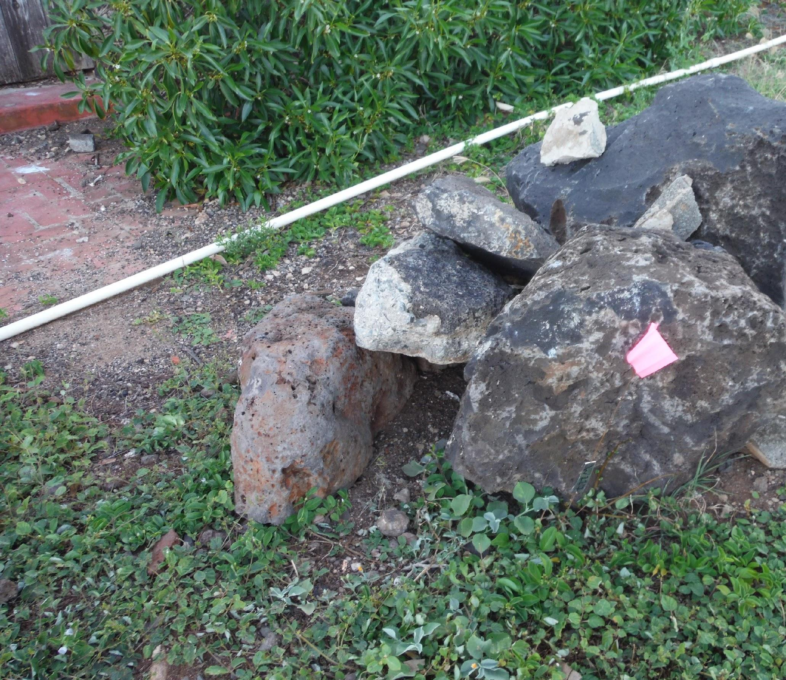  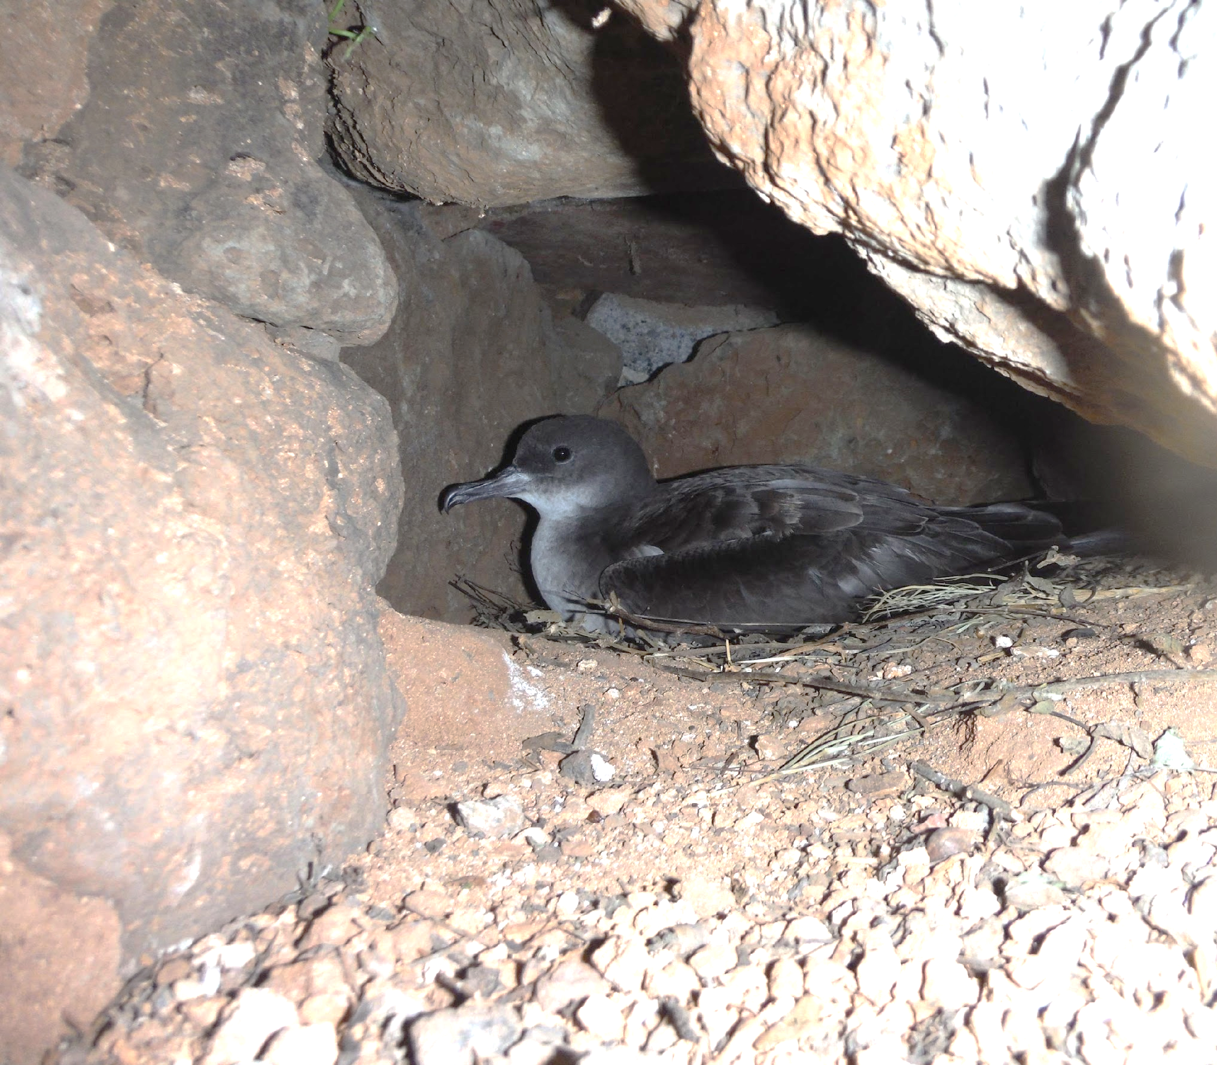 | No Some Full  protection protection protection  1 2 3 4 5  Rat predation 1 2 3 4 5  Cat predation 1 2 3 4 5  Dog predation 1 2 3 4 5  Rain & flooding 1 2 3 4 5  Sunlight & heat 1 2 3 4 5  Total Score: 15  What are this nest’s best features:  Provides a shady and cool nesting site, with some protection from dogs and cats, but susceptible to rats. Rain and flooding can be a problem. Dogs can dig out chicks. Cats can enter burrow part-way on entirely.
Artificial - Rocks and tile roof  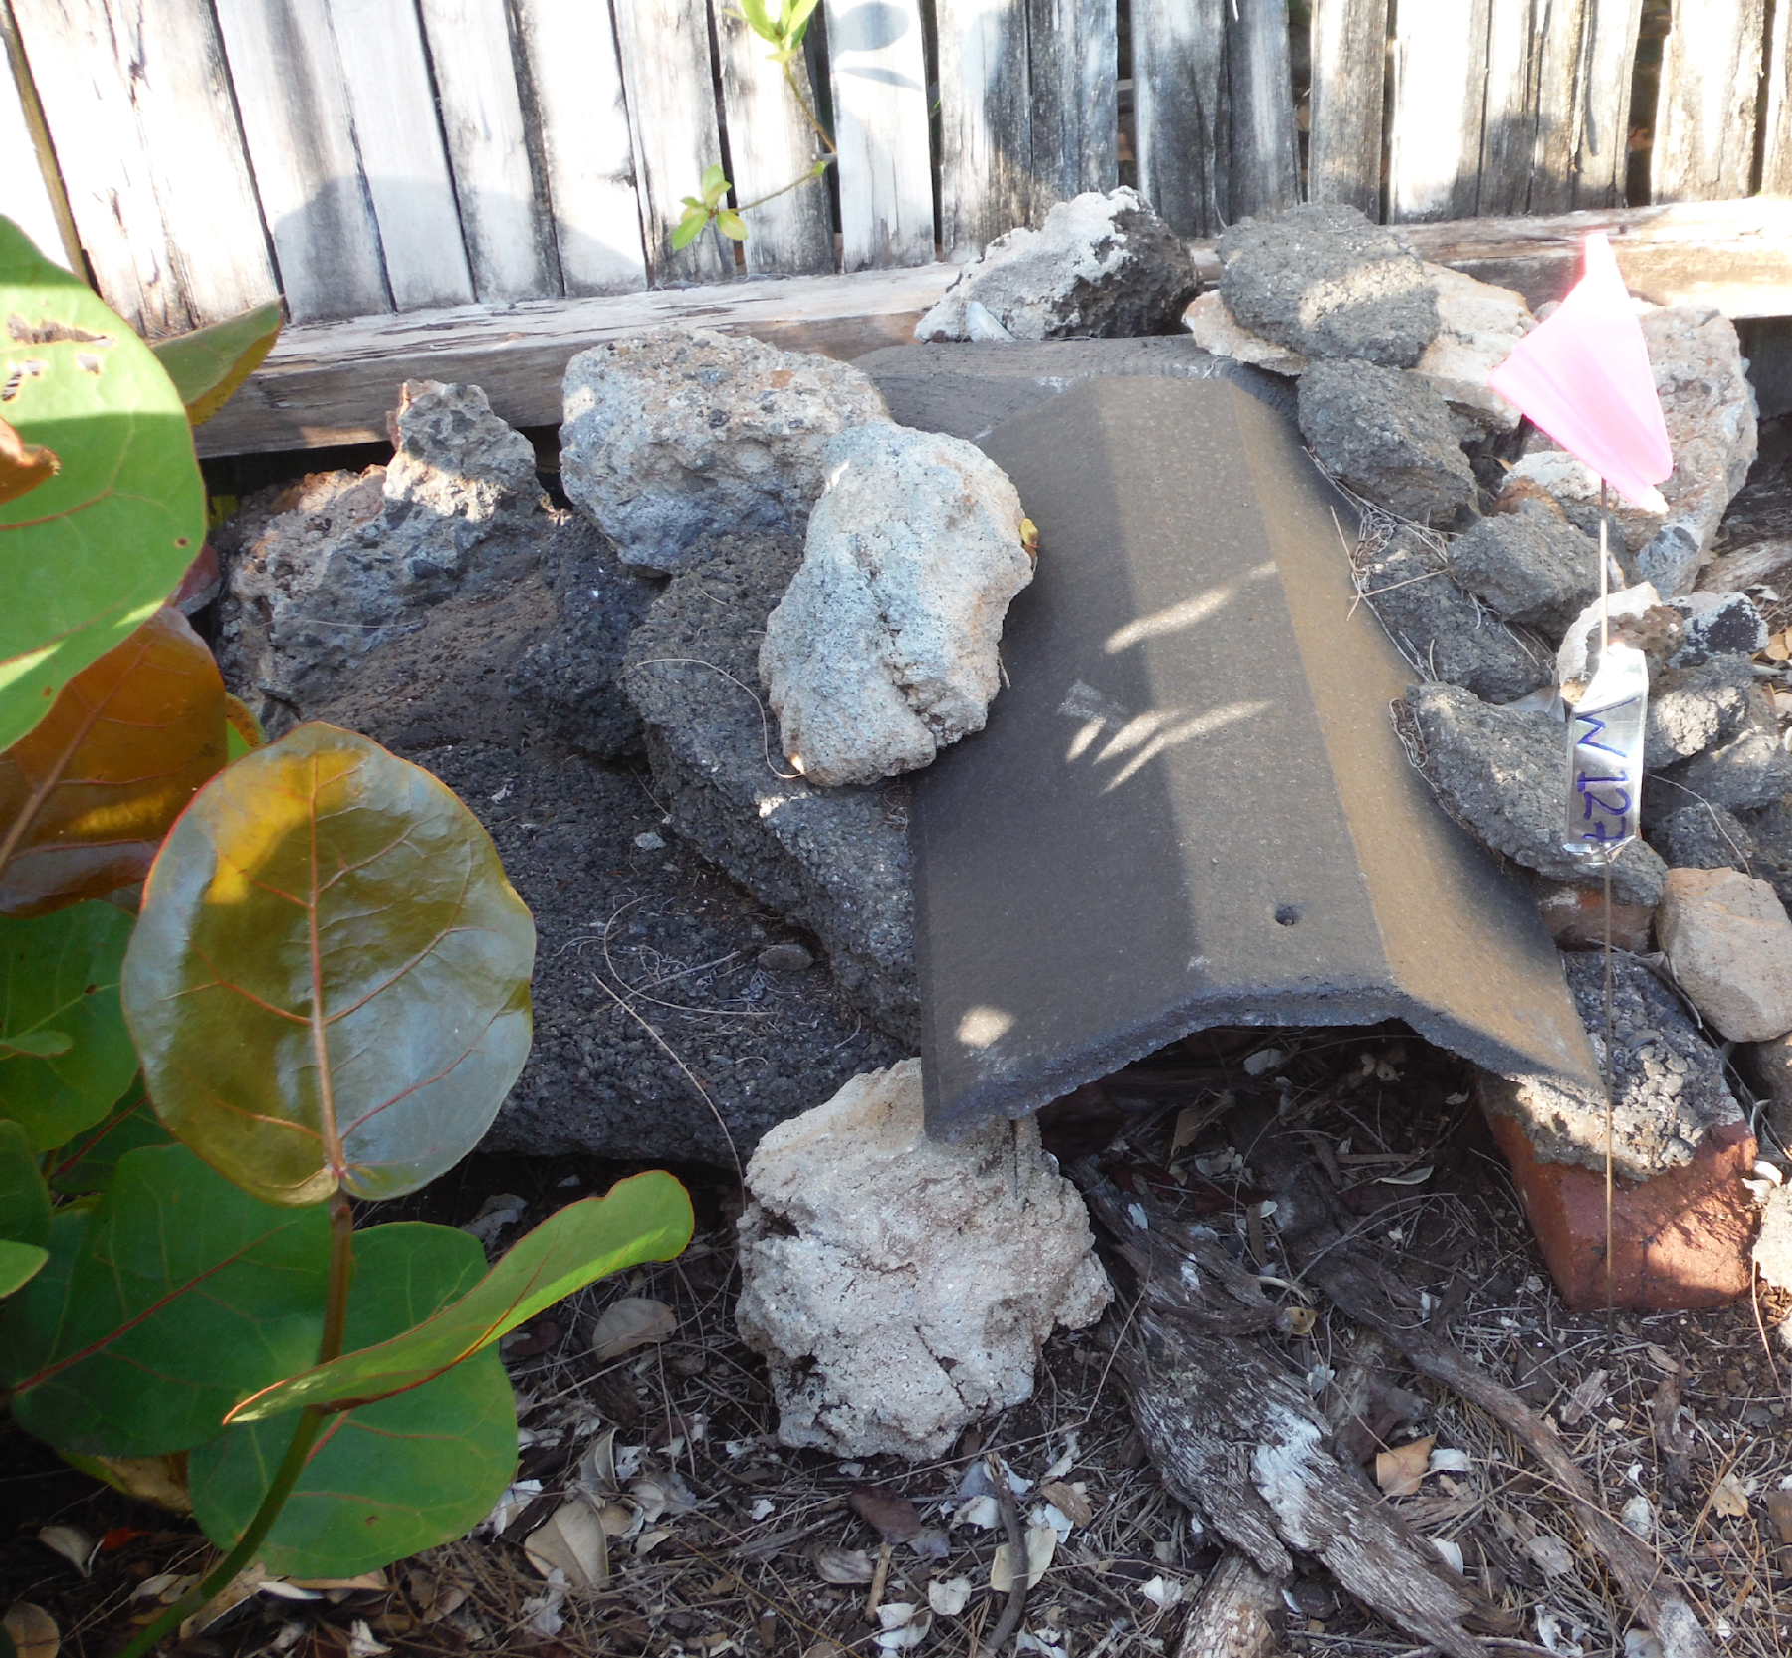  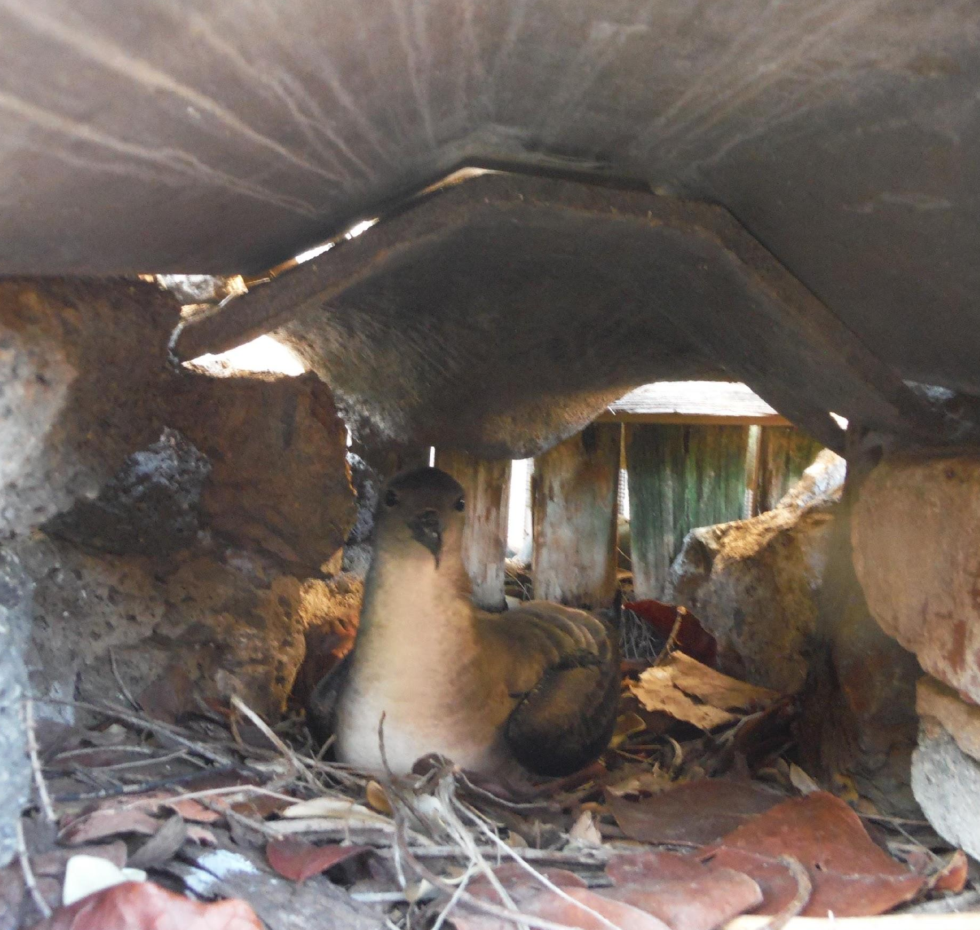 | No Some Full  protection protection protection  1 2 3 4 5  Rat predation 1 2 3 4 5  Cat predation 1 2 3 4 5  Dog predation 1 2 3 4 5  Rain & flooding 1 2 3 4 5  Sunlight & heat 1 2 3 4 5  Total Score: 15  What are this nest’s best features:  Provides a shady and dry nesting site, with some protection from dogs and cats, but susceptible to rats. Dogs can dig out chicks. Cats can enter burrow part-way on entirely. Rain and flooding are mitigated with the tile roof, but site can overheat from low air flow.
Artificial - Ceramic shelters  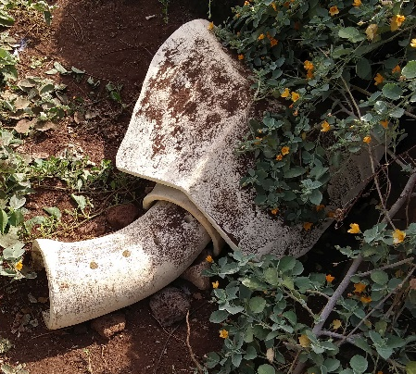  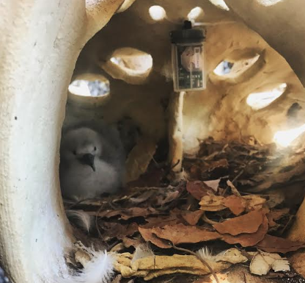 | No Some Full  protection protection protection  1 2 3 4 5  Rat predation 1 2 3 4 5  Cat predation 1 2 3 4 5  Dog predation 1 2 3 4 5  Rain & flooding 1 2 3 4 5  Sunlight & heat 1 2 3 4 5  Total Score: 21  What are this nest’s best features: Provides a shady and dry nesting site, with protection from dogs and cats, but susceptible to rats. Rain and flooding are mitigated. Openings allow air flow and cool the nest.
Discussion Questions

- Which nest scored the highest? What were its design strengths?

The natural burrow has the highest score (18 out of 25). This is a cool, dark and dry nesting site, which offers protection from cats and dogs and flooding.

- Which nest scored the lowest? What were its design weaknesses?
The natural open air nesting site has the lowest score (6 out of 25).

This nest can provide some protection from sunshine and heat, if there is vegetation cover from native bushes.

- Which threat was the easiest to mitigate with the nest designs? Explain.

Dog predation and sun / heat were mitigated in several designs.

- Which threat was the most difficult to mitigate with the nest designs? Explain.

Cat predation was not mitigated fully in any of the natural nests, and only mitigated in the artificial nests. Rat predation was not mitigated in any design.

- What other design issues may influence a shearwater’s nesting site selection?

This is an open-ended question, for the students to discuss.

Some issues to consider include:

- Are there plants in the vicinity?
They can provide shade and protection from heavy rain.
- Is the opening of the nest oriented towards the prevailing wind?
This can help cool the nest.
- Are there human lights in the vicinity of the nest?
They can disorient parents flying back to the nest and they can disturb the birds sleeping at night.
- Are there introduced plants that can choke up the nest site (like Chinese violets) or can harbor invasive ants (like the sea grape), which occasionally attack eggs and young chicks.

