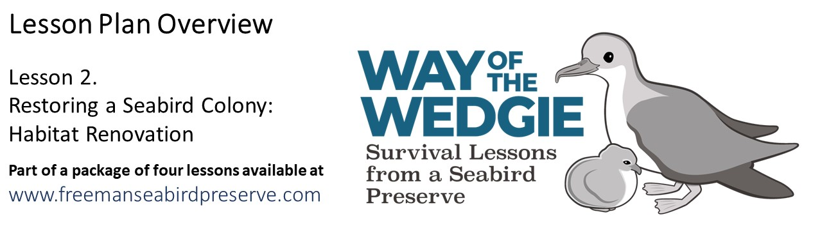
Explore: Nest Preference at Freeman Seabird Preserve

In the previous lesson, we learned about shearwater reproductive success. To understand how the types of nests used influence their ability to successfully reproduce, we will compare the survivorship of the eggs and chicks in a sample of 52 nests selected randomly from the colony.

Nest type | Structure type | Hatched (Y / N) | Fledged (Y / N) |  | Nest type | Structure type | Hatched (Y / N) | Fledged (Y / N)
artificial | rockpile | Y | Y |  | natural | burrow | Y | Y
artificial | rockpile | Y | Y |  | natural | burrow | Y | Y
artificial | rockpile | Y | Y |  | natural | burrow | Y | Y
artificial | rockpile | Y | Y |  | natural | burrow | N | N
artificial | rockpile | Y | Y |  | natural | open air | Y | N
artificial | rockpile | Y | N |  | natural | open air | N | N
artificial | rockpile | Y | Y |  | natural | open air | Y | N
artificial | rockpile | Y | Y |  | natural | open air | Y | N
artificial | rockpile | N | N |  | natural | rock cave | Y | Y
artificial | rockpile | Y | Y |  | natural | rock cave | Y | Y
artificial | rockpile | Y | Y |  | natural | rock cave | Y | Y
artificial | rockpile | N | N |  | natural | rock cave | Y | Y
artificial | rockpile | Y | Y |  | natural | rock cave | Y | Y
artificial | tile roof | Y | Y |  | natural | rock cave | Y | Y
artificial | tile roof | Y | Y |  | natural | rock cave | N | N
artificial | tile roof | Y | Y |  | natural | rock cave | Y | Y
artificial | tile roof | Y | Y |  | natural | rock cave | Y | Y
artificial | tile roof | N | N |  | natural | rock cave | Y | Y
artificial | tile roof | Y | Y |  | natural | rock cave | Y | Y
artificial | tile roof | N | N |  | natural | rock cave | Y | Y
artificial | tile roof | N | N |  | natural | rock cave | Y | Y
artificial | tile roof | Y | Y |  | natural | rock cave | Y | N
artificial | tile roof | Y | Y |  | natural | rock cave | Y | Y
artificial | tile roof | Y | Y |  | natural | rock cave | N | N
artificial | tile roof | Y | Y |  | natural | rock cave | N | N
artificial | tile roof | Y | N |  | natural | rock cave | Y | Y

Previously, we learned to calculate reproductive success, which is defined as the percentage of eggs laid that hatch and become chicks that fledge. We also learned that reproductive success is influenced by the success of eggs (fledging success = defined as the percentage of laid eggs that hatch) and by the success of chicks (fledging success = defined as the percentage of the chicks hatched in August that fledge in November).

Use the directions below to determine the reproductive success of Wedge-tailed Shearwaters in different types of nests.

Calculating the Success of Different Nest Types (Artificial and Natural) by Type of Structure

- Use the table provided below, to investigate if the type and structure of a nest influences the reproductive success of Wedge-tailed Shearwaters.
- Note that the number of nest structures varies, because some are more abundant than others. For instance, there are only 4 burrows (natural tunnels) and 4 nests on the open air (without any rocks or vegetation). You will calculate 3 metrics of shearwater success:

- Hatching Success (%) = 100 * (Number of Chicks Hatched / Number of Eggs Laid)
- Fledging Success (%) = 100 * (Number of Chicks Fledged / Number of Chicks Hatched)
- Reproductive Success (%) = 100 * (Number of Chicks Fledged / Number of Eggs Laid)

ARTIFICIAL NESTS | Eggs Laid | Chicks Hatched | Chicks Fledged | Hatching Success | Fledging Success | Reproductive Success
rockpile | 13 | 11 | 10
tile roof | 13 | 10 | 9
NATURAL NESTS | Eggs Laid | Chicks Hatched | Chicks Fledged | Hatching Success | Fledging Success | Reproductive Success
rock cave | 18 | 15 | 14
open air | 4 | 0 | 0
burrow | 4 | 4 | 4

- Next, you will graph your data, to show the differences in reproductive success by nest structure and type. Create a title for your graph.

- You are making a bar graph; divide the X-axis so that you create 5 bars, one for each of the following data sets: two artificial nest structures and three natural nest structures.

- Label your Y-axis with the title of “Reproductive Success (%)” and number the axis from 0 to 100. I suggest you make your graph tall enough to see the different heights of the histograms. You can make the Y-axis 50 cells tall, so each one is equal to 2 units.

- Label the X-axis “Nest Type and Structure”, and mark the tick marks and names of the various types: A-rock, A-tile, N-rock, N-open, N-burrow”. I suggest you leave enough space to make the histograms wide enough and that you group the nest structures from the two types together: Artificial and Natural.

- Make sure you provide add a legend for the nest types and structures:

A-R: Artificial – rockpile
A-T: Artificial – tiles
N-R: Natural – rock cave
N-O: Natural - open air
N-B: Natural – burrow

- I suggest you use different color pencils for the different nest types, and different hatching (or shading) for each structure within a given nest type.

- Use your graph to help you answer the following questions.

Discussion Questions

- What structure has the highest reproductive success? Is this a natural or an artificial nest?

________________________________________________________________________

- Why are there so few of this type of highly successful nest structures at the preserve? What is limiting the more shearwaters from using these type of nests?

________________________________________________________________________

- What structure has the lowest reproductive success? Is this a natural or an artificial nest?

________________________________________________________________________

- Why are there so few of this type of highly unsuccessful nest structures at the preserve? What is limiting the more shearwaters from using these type of nests?

________________________________________________________________________

- How well do the natural rock cave nests do, compared to the other natural nests?

________________________________________________________________________

- How well do the natural rock cave nests do, compared to the two artificial nests?

________________________________________________________________________

