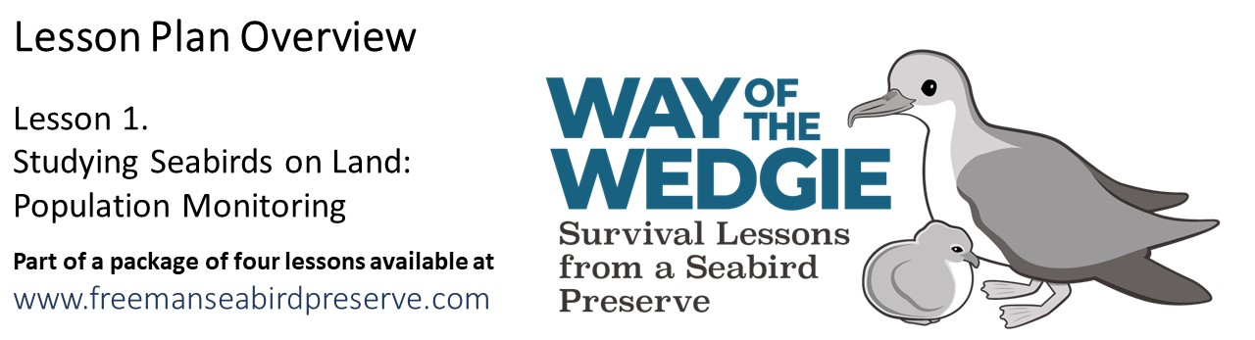

Materials:
- Graph paper (included)
- Calculator
- Ruler
Document List & Learning Objectives:
- Engage: Wedge-tailed Shearwater Life Cycle
  - This Powerpoint presentation walks students through the different phases of the life of the Wedge-tailed Shearwater, with an emphasis on reproduction on land.
- Explore & Explain: Graphing Population Growth
  - Students will observe trends in nesting data and graph values for total nests, (adults incubating eggs and chicks) and nesting success over 6 years.
- Evaluate: The Life Cycle of a Wedge-tailed Shearwater
  - Students will demonstrate their new knowledge by drawing and describing one year in the life of a Wedge-tailed Shearwater.
- Elaborate: Chick Dates & Weights
  - Students will learn more about nesting by calculating the mean and median hatch dates and final chick masses.

Skills addressed in this lesson:
- Calculating percentages
- Calculating the mean and the median
- Graphing data
- Numerical literacy

Activity Modifications
- Explore & Explain: Graphing Population Growth
  - Show students data from the most recent year at the preserve and see how their estimates matched up.
- Evaluate: The Life Cycle of a Wedge-tailed Shearwater
  - Allow students the creative freedom to display their story in another format such as a poster, a video, a poem, or a story.
- Elaborate: Nest Checks
  - Students analyze data from repeated checks of shearwater nests at the preserve.

