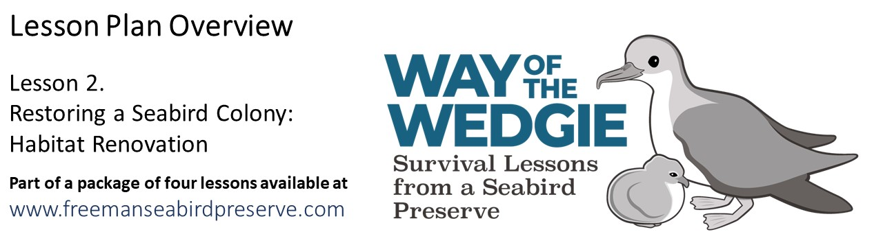**Explore: Nest Preference at Freeman Seabird Preserve**

In the previous lesson, we learned about shearwater reproductive success. To understand how the types of nests used by shearwaters influence their ability to successfully reproduce, we will compare the survivorship of the eggs and chicks in a sample of 52 nests selected randomly from the colony.

|  |  |  |  |  |  |  |  |  |
| --- | --- | --- | --- | --- | --- | --- | --- | --- |
| **Nest type** | **Structure type** | **Hatched (Y / N)** | **Fledged (Y / N)** |  | **Nest type** | **Structure type** | **Hatched (Y / N)** | **Fledged (Y / N)** |
| artificial | rockpile | Y | Y |  | natural | burrow | Y | Y |
| artificial | rockpile | Y | Y |  | natural | burrow | Y | Y |
| artificial | rockpile | Y | Y |  | natural | burrow | Y | Y |
| artificial | rockpile | Y | Y |  | natural | burrow | N | N |
| artificial | rockpile | Y | Y |  | natural | open air | Y | N |
| artificial | rockpile | Y | N |  | natural | open air | N | N |
| artificial | rockpile | Y | Y |  | natural | open air | Y | N |
| artificial | rockpile | Y | Y |  | natural | open air | Y | N |
| artificial | rockpile | N | N |  | natural | rock cave | Y | Y |
| artificial | rockpile | Y | Y |  | natural | rock cave | Y | Y |
| artificial | rockpile | Y | Y |  | natural | rock cave | Y | Y |
| artificial | rockpile | N | N |  | natural | rock cave | Y | Y |
| artificial | rockpile | Y | Y |  | natural | rock cave | Y | Y |
| artificial | tile roof | Y | Y |  | natural | rock cave | Y | Y |
| artificial | tile roof | Y | Y |  | natural | rock cave | N | N |
| artificial | tile roof | Y | Y |  | natural | rock cave | Y | Y |
| artificial | tile roof | Y | Y |  | natural | rock cave | Y | Y |
| artificial | tile roof | N | N |  | natural | rock cave | Y | Y |
| artificial | tile roof | Y | Y |  | natural | rock cave | Y | Y |
| artificial | tile roof | N | N |  | natural | rock cave | Y | Y |
| artificial | tile roof | N | N |  | natural | rock cave | Y | Y |
| artificial | tile roof | Y | Y |  | natural | rock cave | Y | N |
| artificial | tile roof | Y | Y |  | natural | rock cave | Y | Y |
| artificial | tile roof | Y | Y |  | natural | rock cave | N | N |
| artificial | tile roof | Y | Y |  | natural | rock cave | N | N |
| artificial | tile roof | Y | N |  | natural | rock cave | Y | Y |

Previously, we learned to calculate reproductive success, which is defined as the percentage of eggs laid that hatch and become chicks that fledge. We also learned that reproductive success is influenced by the success of eggs (fledging success = defined as the percentage of laid eggs that hatch) and by the success of chicks (fledging success = defined as the percentage of the chicks hatched in August that fledge in November).

Use the directions below to determine the reproductive success of Wedge-tailed Shearwaters in different types of nests.

**Calculating the Success of Different Nest Types (Artificial and Natural) by Type of Structure**

* Use the table provided below, to investigate if the type and structure of a nest influences the reproductive success of Wedge-tailed Shearwaters.
* Note that the number of nest structures varies, because some are more abundant than others. For instance, there are only 4 burrows (natural tunnels) and 4 nests on the open air (without any rocks or vegetation). You will calculate 3 metrics of shearwater success:

1. Hatching Success (%) = 100 * (Number of Chicks Hatched / Number of Eggs Laid)
2. Fledging Success (%) = 100 * (Number of Chicks Fledged / Number of Chicks Hatched)
3. Reproductive Success (%) = 100 * (Number of Chicks Fledged / Number of Eggs Laid)

|  |  |  |  |  |  |  |
| --- | --- | --- | --- | --- | --- | --- |
| **ARTIFICIAL NESTS** | **Eggs Laid** | **Chicks Hatched** | **Chicks Fledged** | **Hatching Success** | **Fledging Success** | **Reproductive Success** |
| **rockpile** | 13 | 11 | 10 | 84.6 | 90.9 | 76.9 |
| **tile roof** | 13 | 10 | 9 | 76.9 | 90.0 | 69.2 |
|  |  |  |  |  |  |  |
| **NATURAL NESTS** | **Eggs Laid** | **Chicks Hatched** | **Chicks Fledged** | **Hatching Success** | **Fledging Success** | **Reproductive Success** |
| **rock cave** | 18 | 15 | 14 | 83.3 | 93.3 | 77.8 |
| **open air** | 4 | 0 | 0 | 0.0 | 0.0 | 0.0 |
| **burrow** | 4 | 4 | 4 | 100.0 | 100.0 | 100.0 |

* Next, you will graph your data, to show the differences in reproductive success by nest structure and type.

**NEST TYPE AND STRUCTURE**

A-R: Artificial – rockpile

A-T: Artificial – tiles

N-R: Natural – rock cave

N-O: Natural - open air

N-B: Natural – burrow



**Discussion Questions**

1. What structure has the highest reproductive success? Is this a natural or an artificial nest?

Natural burrows have the highest reproductive success: 100% of these eggs hatched and 100% of these chicks survived and fledged.

1. Why are there so few of this type of highly successful nest structures at the preserve? What is limiting the more shearwaters from using these type of nests?

Shearwaters dig burrows in sandy soil, like beach dunes, but have a difficult time digging in rocky soils. Remember, even though we added soil and sand to the preserve, this is a very rocky site, full of volcanic rocks. Few shearwaters find soft soil for burrowing.

1. What structure has the lowest reproductive success? Is this a natural or an artificial nest?

Natural open nesting sites have the lowest reproductive success: 0% of the eggs failed to hatch and 0% of the chicks fledged.

1. Why are there so few of this type of highly unsuccessful nest structures at the preserve? What is limiting the more shearwaters from using these type of nests?

These nesting sites often have some plant ground cover and may have some shade from nearby bushes. It is very likely that inexperienced shearwaters, who cannot secure better nesting sites, use these sites.

1. How well do the natural rock cave nests do, compared to the other natural nests?

Natural rock caves do better than open air nesting sites, but worse than natural burrows. Overall, 77.8% of the eggs laid in natural rock caves hatch and fledge. The hatching success (83.3%) and fledging success (93.3%) show that some eggs and chicks fail to survive.

1. How well do the natural rock cave nests do, compared to the two artificial nests?

The reproductive success of the natural rock caves (77.8%) is similar to the reproductive success of the artificial nest sites: rockpiles (76.9%) and tile roof (69.2) nesting sites. Some eggs and chicks fail in both artificial nest structures.