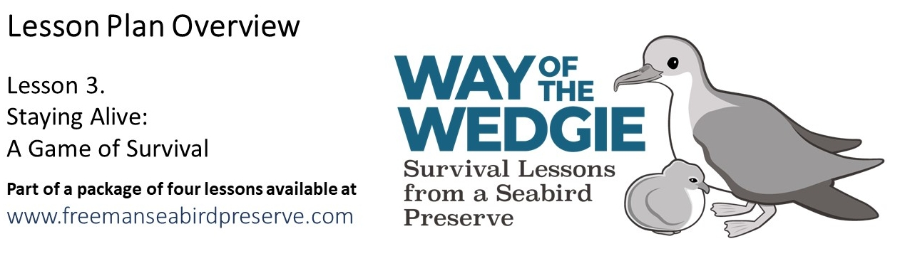
Elaborate: Staying Alive - Chick Survival

Dr. David Hyrenbach shared data from the Wedge-tailed Shearwater population breeding at the Freeman Seabird Preserve. For this exercise, you will analyze the data from 16 weekly visits to 31 monitored nests to calculate the survival rate of eggs and chicks. Follow the directions below to learn more about the survival of Wedge-tailed Shearwaters at Freeman Seabird Preserve during the 2009 season.

The dataset covers 16 weeks, from the July 14 population census, when monitoring nests are marked, to the beginning of November. Surviving chicks were banded on November 9.

NOTE: The nests are coded with symbols, as follows:

Key for Data Table
Symbol | Meaning
E | Egg
C | Chick
L | Lost egg, nest found empty
P | Predated egg or chick
B | Broken egg
D | Dead chick

Egg and Chick Survival Data

Nest  # |  | Date of Data Collection (month / day)
 | 7/21 | 7/28 | 8/4 | 8/11 | 8/18 | 8/25 | 9/1 | 9/8 | 9/15 | 9/22 | 9/30 | 10/7 | 10/14 | 10/20 | 10/26 | 11/2
1 | E | E | E | E | E | C | C | C | C | C | C | C | C | C | C | C
2 | E | E | E | E | E | E | E | E | E | P | P | P | P | P | P | P
3 | E | E | E | E | E | C | C | C | C | C | C | C | C | C | C | C
4 | E | E | E | E | E | E | E | E | E | E | E | B | B | B | B | B
5 | E | E | E | E | C | C | C | C | C | C | C | C | C | C | C | C
6 | E | E | E | E | E | E | C | C | C | C | C | C | C | C | C | C
7 | E | E | E | E | E | C | C | C | C | C | C | P | P | P | P | P
8 | E | E | E | E | C | C | C | C | C | C | C | C | C | C | C | C
9 | E | E | E | E | E | P | P | P | P | P | P | P | P | P | P | P
10 | E | E | -- | E | E | C | C | C | C | C | C | C | C | C | C | C
11 | E | E | E | E | E | C | C | C | C | C | C | C | C | C | C | C
12 | E | E | E | E | C | C | C | C | C | C | C | C | C | C | C | C
13 | E | E | E | E | E | E | E | E | E | L | L | L | L | L | L | L
14 | E | E | E | E | E | E | E | P | P | P | P | P | P | P | P | P
15 | E | E | E | E | E | E | C | C | C | C | C | C | C | C | C | C
16 | E | -- | E | C | C | C | C | C | C | C | C | C | C | C | C | C
17 | E | E | E | E | E | E | E | C | C | C | C | C | C | C | C | C
18 | E | E | E | E | E | E | L | L | L | L | L | L | L | L | L | L
19 | E | E | E | E | E | C | C | C | C | C | C | C | C | C | C | C
20 | E | E | E | E | E | E | C | C | C | C | C | C | C | C | C | C
21 | E | E | E | E | E | E | L | L | L | L | L | L | L | L | L | L
22 | E | E | E | E | C | C | C | C | C | C | C | C | C | C | C | C
23 | E | E | E | E | E | C | C | C | C | C | C | C | C | C | C | C
24 | E | E | E | E | E | E | C | -- | C | -- | C | C | C | C | C | C
25 | E | E | E | E | E | E | D | D | D | D | D | D | D | D | D | D
26 | E | E | E | E | E | E | C | C | C | C | C | C | C | C | C | C
27 | E | E | E | E | E | C | C | C | C | C | C | C | C | C | C | C
28 | E | E | E | E | E | E | C | C | C | -- | C | C | C | C | C | C
29 | E | E | E | E | E | E | E | E | L | L | L | L | L | L | L | L
30 | E | E | E | E | E | E | C | -- | C | C | C | C | C | C | C | C
31 | E | E | E | E | E | C | C | C | C | C | C | C | C | C | C | C

Directions for Analyzing Data

To visualize the data, color code each cell, as follows:
- Lightly color in all “E” – egg data in blue
- Lightly color in all “C” – chick data in green
- Lightly color in all “L” – lost, “P” – predated, “B” – broken or “D” – dead data red
- Lightly color the dashes “--“. in yellow. These are days when no data could be collected either because the chicks were hidden deep in the nest or because the incubating adults did not let us see the eggs.
Discussion Questions

- Guess the missing data values (highlighted with dashes), using the values the week before and after.

In every case, the missing data values could be guessed using the values from the week before and after, which were the same (E – E, leading to guess “E”; or C – C: leading to guess “C”). Note that if there had been a transition from E to C, for instance, we would not be able to guess the missing value.

- When did the chicks hatch from their eggs (what is the earliest / latest date a chick hatched)?
Hint: Because we visit the colony weekly (every 7 days), if we see an egg in one week and a chick (day 1) in the following week (day 8), we do not know what day the chick actually hatched. To deal with this uncertainty, we assign this chick a hatch date of day 4, half-way between day 1 and day.
This half-way point is the median in this example would be 4.5: 1, 2, 3, 4 MEDIAN 5, 6, 7, 8

23 of 31 eggs laid hatched. Note: nest 25 hatched from Aug.18 (Egg) and Aug. 25 (dead chick).
Hatch dates ranged from Aug. 4 – 11 (median date: 7.5) and from Aug. 25 – Sept 1 (median date: 28.5).
Note that nest 25 hatched: there was an egg (E) on August 18 and dead chick (D) on August 25.

These are the estimated (median) hatching dates for the 22 nests where chicks hatched, and the two dates (date 1: egg present, and date 2: chick present). Note: Day2 for Nest 17 is September 1 (day 32).

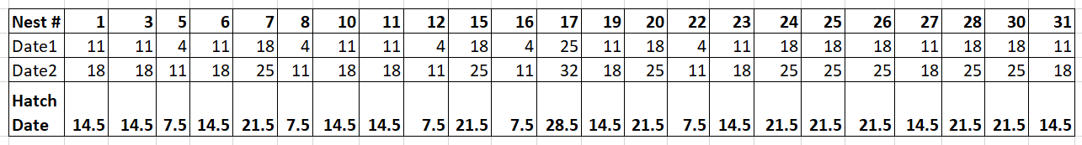

- How many eggs hatched? 23 / 31. What percentage of laid eggs hatched? 100 * (22 / 31) = 74.2 %
- Most of the unsuccessful eggs did not survive due to (what cause?)
Hint: Calculate the proportions of eggs that were predated, broken or simply lost.
8 eggs failed to hatch: 1 (12.5%) was broken, 3 (37.5%) were predated by rats, and 4 (50%) were “lost”.
This means that the nests were empty, and no eggs of chicks were found.
Likely these eggs were kicked out of the nest or predates by rats.

- How many hatched chicks survived? 31 of 32 hatched chicks survived to November.
The chick that died was not predated. It was found dead in the nest, likely from starvation.
What percentage of hatched chicks survived? 96.9 %
6. Based on your experience as a Wedge-tailed Shearwater in the last lesson and the interpretation of
the data, explain what is the greatest threat to their survival at the Freeman Seabird Preserve.

The loss of eggs to predation by rats was a major loss in 2009: with 4 confirmed cases and 3 additional
possible cases (with lost eggs). One egg was found broken (with a crack) in the nest, likely from ants
or from damage due to shearwaters fighting over a nesting place. It is possible that all or some of the
three missing eggs were also kicked out of the nests, during shearwater arguments over nesting sites.
In 2009, no chicks were predated upon. Only 1 chick was found dead in its nest.

