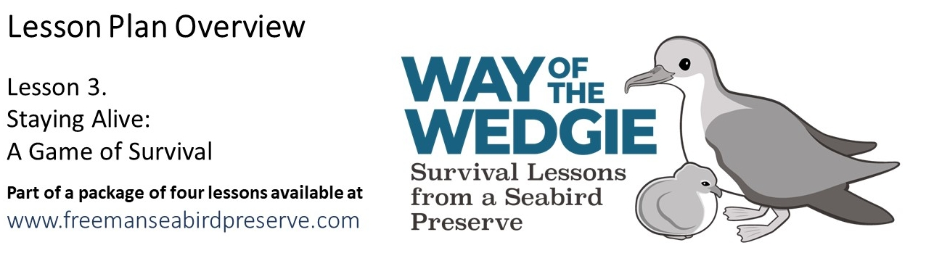
Materials:

- The basic Shearwater Journey Game dice & worksheet (included)
- Blank dice & worksheet for the advanced Shearwater Journey Game
- Tape (for assembling game dice)
- Paper & Markers for game stations
- Calculator
Document List & Learning Objectives:

- Engage: Threats to Shearwaters
  - Powerpoint presentation highlights the major threats to Wedge-tailed Shearwaters both on land and at sea
- Explore & Explain: The Shearwater Journey - Interactive Game
  - Students take on the role of a Wedge-tailed Shearwater through an interactive game, exploring the challenges with mating, laying an egg, hatching a chick, and facing threats from humans and predators. As a class, students will analyze and discuss the data they have collected during the game.
  - Students can use the results from the basic game to brainstorm potential management actions. Then, they can modify one of more of the dice, to remove the causes of mortality on land (at the preserve) or at sea (in the ocean).
- Evaluate: Conservation Brainstorming
  - Students will develop a conservation plan to mitigate one threat to Wedge-tailed Shearwaters. They will then work collaboratively to modify the plan.
- Elaborate: Staying Alive - Chick Survival
  - Students examine egg and chick survival data to calculate reproductive success.
(this activity reinforces the analyses and lessons from previous activities)

Skills addressed in this lesson:

- Calculating percentages
- Group brainstorming / problem-solving
- Identifying trends in data
- Anticipating outcomes from different scenarios

Activity Modifications

- Explore & Explain: The Shearwater Journey - Interactive Game
  - More advanced students can graph & analyze the results from the game. This could include a bar graph of the number of nests in each nest type, calculating percentages of successful eggs, chicks, and adults, and graphing the different causes (and percentages) of causes of death at sea and at the preserve.
- Evaluate: Conservation Brainstorming
  - You may choose to have students work in small groups and have each group cover a different threat, then share their recommendations with the class.
- Elaborate: Staying Alive - Chick Survival
  - For more advanced students, have students graph a survival analysis. This shows survival of eggs/chicks/adults. You can either have students graph the percentage of successfully hatched eggs / fledged chicks / recruited chicks.

